Melville Montessori Pre-Primary School cc

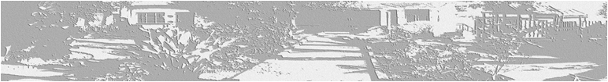
Reg No: CK 97 38497/23
Founded 1995
15/17 Tolip Street, Westdene, Johannesburg, 2092, P O Box 1534, Roosevelt Park, 2129 Cell 083 6061082
email jacqui@melvillemontessori.co.za www.melvillemontessori.co.za

Surname Child’s Name (in full) Child’s Date of Birth Father’s Name Occupation Business Tel Home Tel Mobile No Email Address (W) Address (H) Mother’s Name Occupation Business Tel Home Tel
Mobile No Email
Address (W) Address (H) Name the infectious diseases your child has already had? Allergies Reaction to Allergies Family Doctor’s Name Tel No Emergency Tel No Address
I hereby authorize the Directress of the above school to seek any medical advice/attention which my child may require, where the family doctor or ourselves cannot be contacted.

Parent / Guardian

Consent and Indemnity
I (Full Name) Address The Parent / Guardian of
Hereby give consent for my son / daughter to take part in extra mural activities of The Melville Montessori Pre-Primary School, including games, athletics, as well as to make use of educational and play equipment at the school.

I fully understand and accept that school activities shall be undertaken at my son’s / daughter’s own risk and I undertake on behalf of myself, my executors, my wife and my child aforesaid, to indemnify, hold harmless and absolve the School, the Directress and paid or unpaid temporary assistants against and from any claims whatsoever that may arise in connection with any loss of or any damage to the property or injury to the person of my child aforesaid in the course of any such school activity in the knowledge that the Directress and her paid or unpaid assistants will, nevertheless take all reasonable precautions for the safety and welfare of my child.
Signed at Johannesburg on (date) Parent / Guardian

